|  |  |
| --- | --- |
|  | **Marathwada Shikshan Prasarak Mandal’s**  **Deogiri Institute of Engineering and Management Studies**  **Deogiri Campus,Railway Station Road, Aurangabad - 431001**  [**www.dietms.org**](http://www.dietms.org)**||**[**admin@dietms.org**](mailto:admin@dietms.org)**||0240-2367546 ||Fax: 0240-2367577** |

**Department of Computer Science & Engineering**

**Week-wise Internship Report Academic Year 2019-20**

**Name of Student:** Arti Panjabrao Mule

**Roll number:** 26059

**BATU PRN Number:** 20211420181124210017

**Name of Mentor:** Padmapani Tribhuvan mam

**Detailed name of Internship (Organization/Online platform/Training Institute):** Indian OpenSource Community.

**Duration of Internship (In weeks):** 5/6 weeks

**Date of Joining the Internship:** 13/june/2020

**Date of Completion of Internship**: 18/july2020

**Week 3:**

**Technology / Platform on Which Working**: AWS and EC2 Instance

**Day 1.(4 july,11:00am-02:00pm)**

**Launching one windows instance with IIS server.**

1. Open the [AWS EC2 Management Console](https://console.aws.amazon.com/ec2/v2/home)
2. Click **Launch Instance**

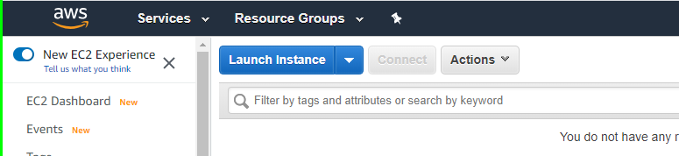

1. Select a Microsoft Windows Server instance (you may want to start with one that is “free tier eligible”

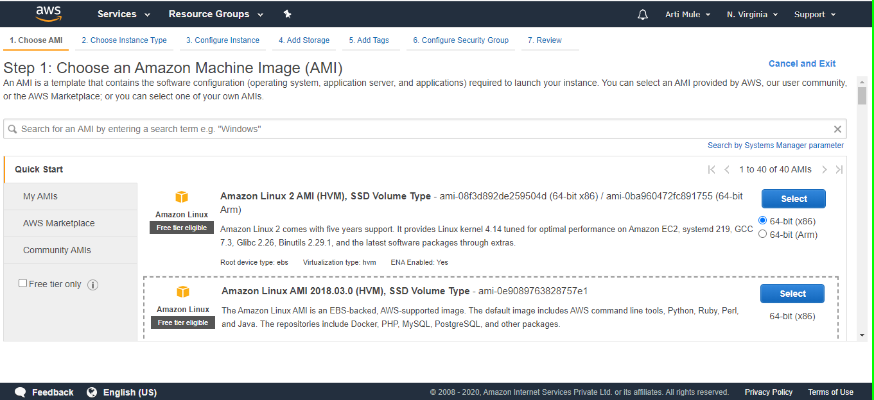

1. Choose an instance type

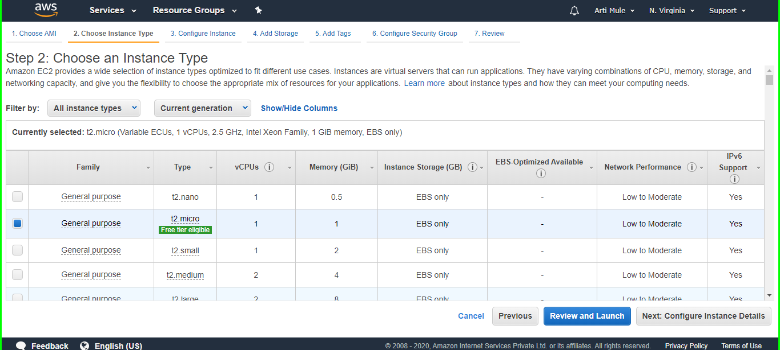

Since we are launching a simple instance click on Next:Configure instance Details, if you may skip all the steps then click **Review and Launch**

1. Select an Configure Instance Detai;s you may be keep default or change it yours choice and click on Next:Add Storage

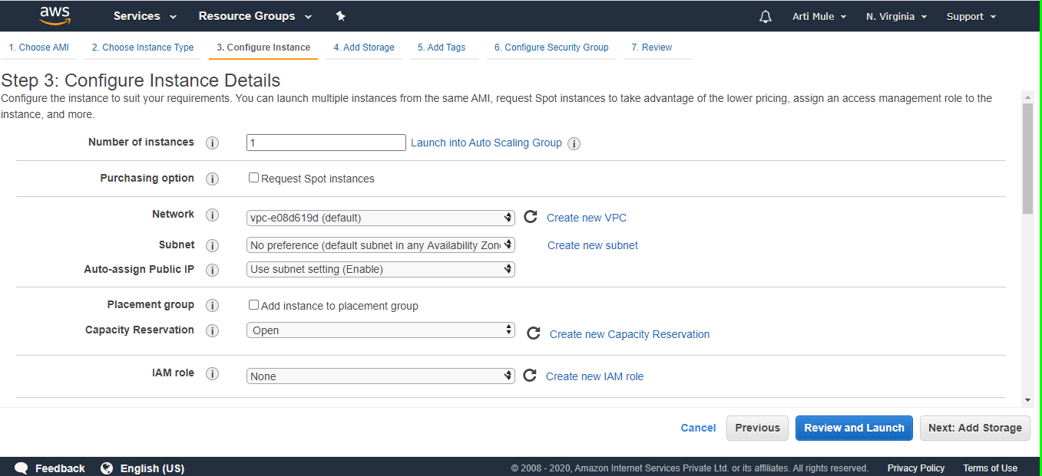

1. Select an Add Storage and click on Next:Add tage

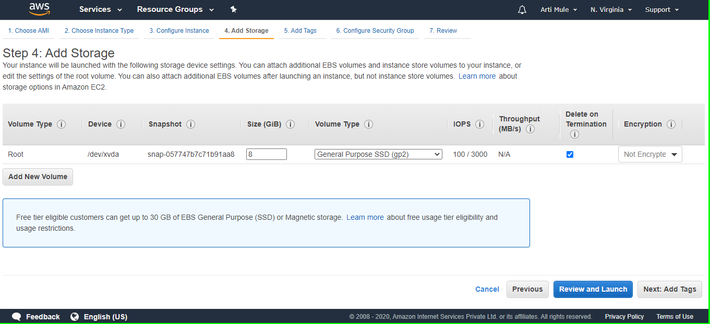

1. Select an Add Tags 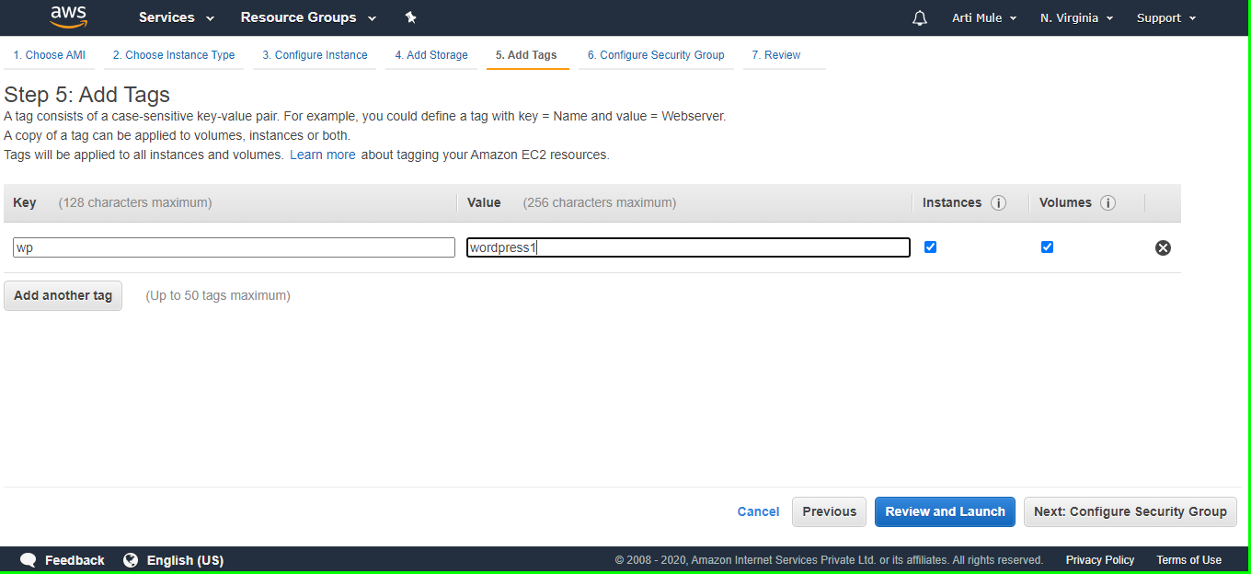
2. Select an Configure and Group you can add more type click Add Rule and you want to choose and select then click on Review and launch.

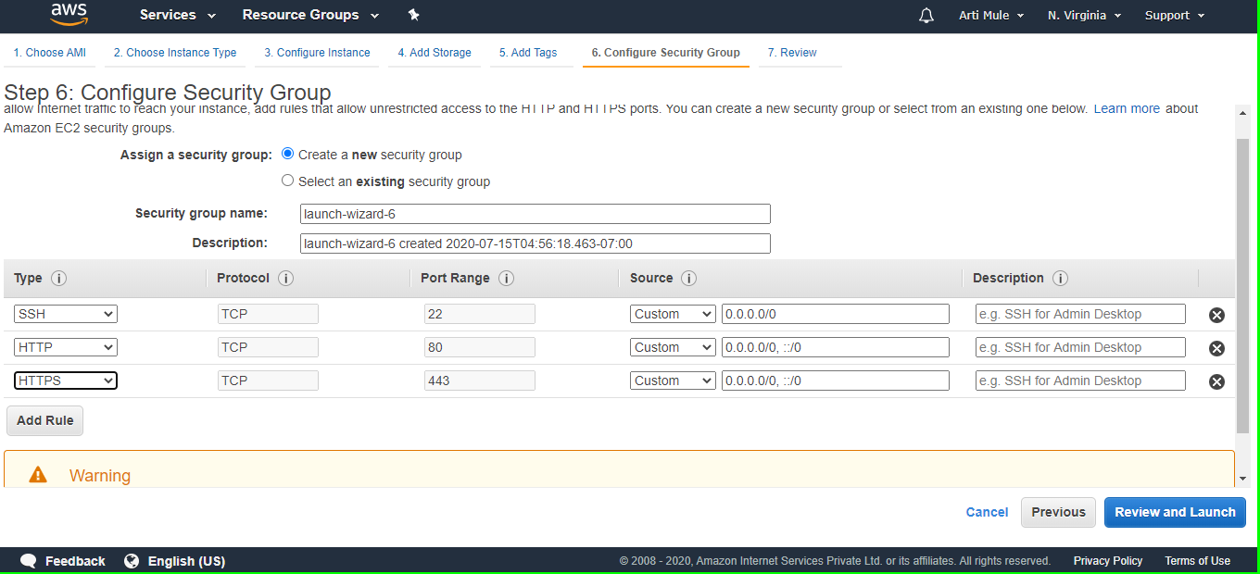

1. Select an Review Instance Launch

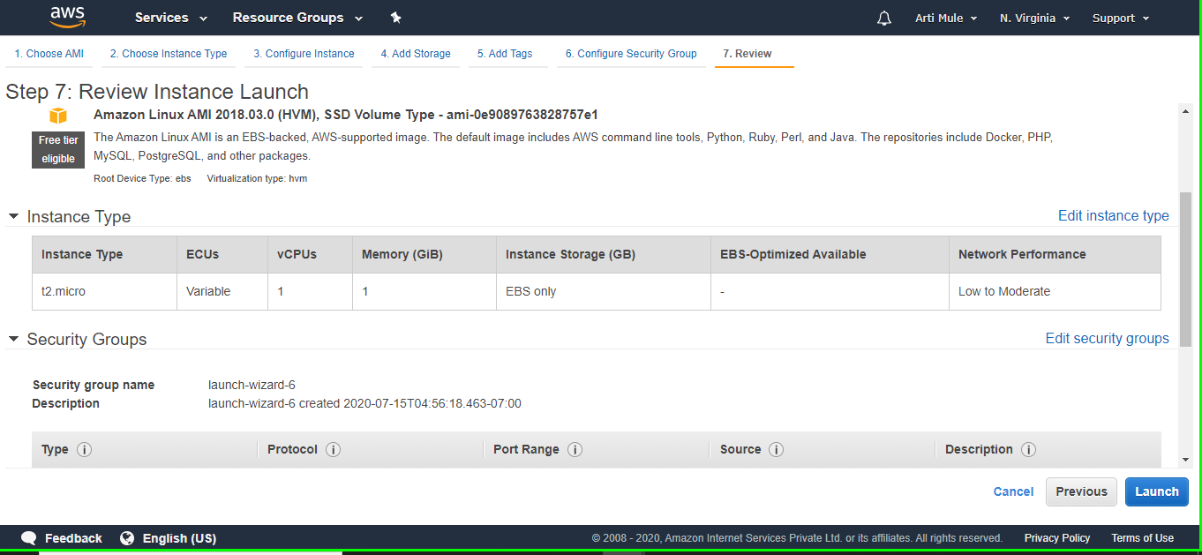

If you want change anything can you choose which you want to change and click on edit and change it ,otherwise click on Launch.

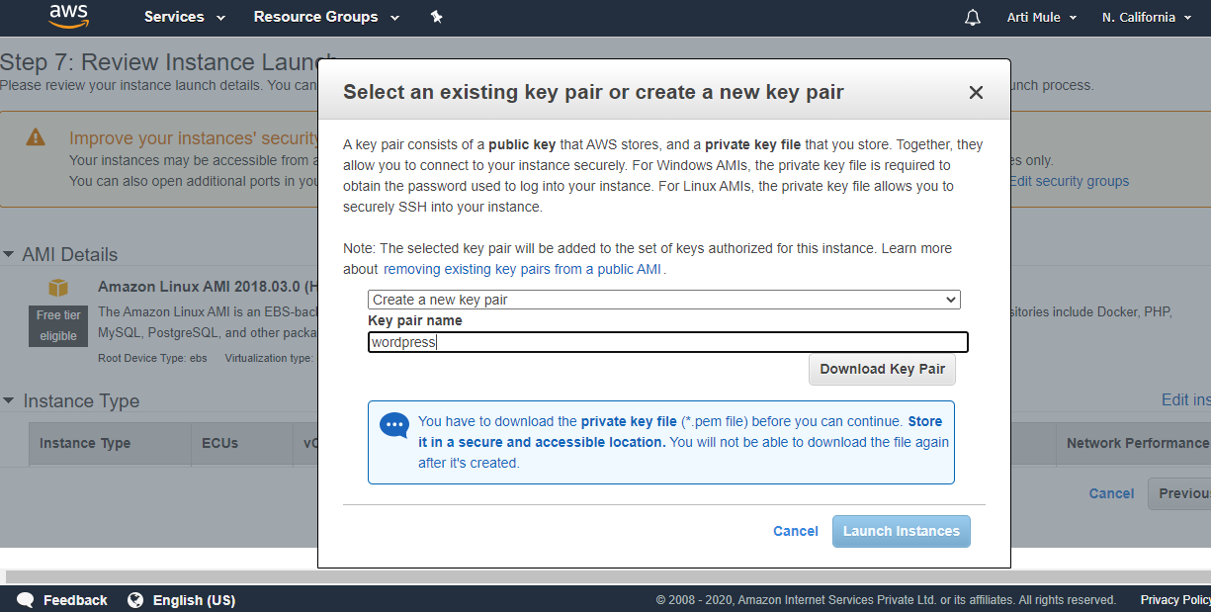

10.Select an existing key pair or Create new key pair ,Download the new key pair and click Launch Instance.

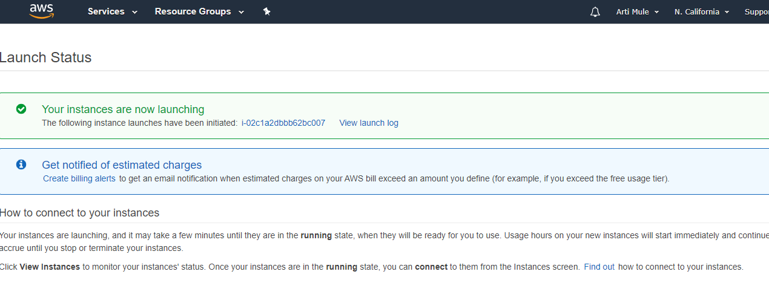

Successfully Launch Instance, Click **View Instances** to open the EC2 Management Console

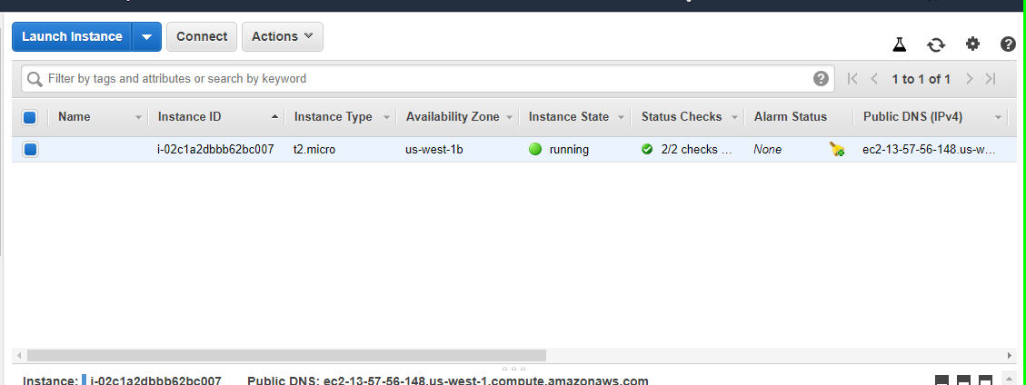

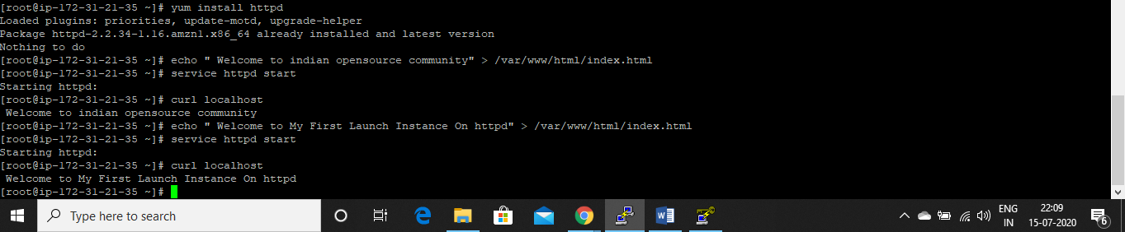

If everything is installed correctly, you should be able to enter the IP address of your EC2 instance in any web browser, and see output.

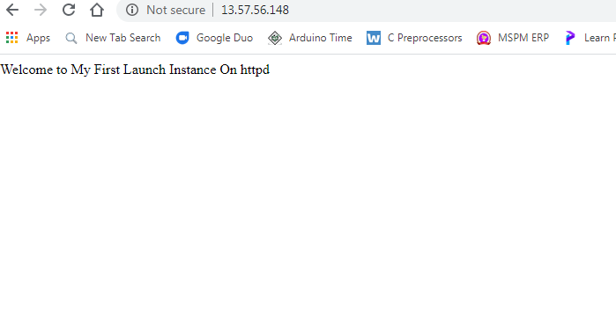

Successfully completed.

**Day 2.(5 july,11:00am-02:00pm)**

EC2 - Classic Load Balance

A load balancer distributes incoming application traffic across multiple EC2 instances in multiple Availability Zones. This increases the fault tolerance of your applications. Elastic Load Balancing detects unhealthy instances and routes traffic only to healthy instances.

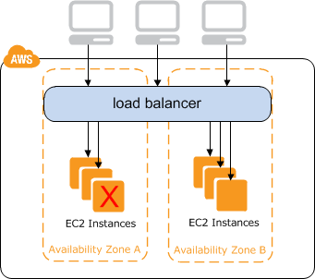

For example, if you have ten instances in Availability Zone us-west-2a and two instances in us-west-2b, the requests are distributed evenly between the two Availability Zones. As a result, the two instances in us-west-2b serve the same amount of traffic as the ten instances in us-west-2a. Instead, you should have six instances in each Availability Zone.

Open the Amazon EC2 console, On the navigation pane, under LOAD BALANCING, choose Load Balancers. And click create Load Balancer

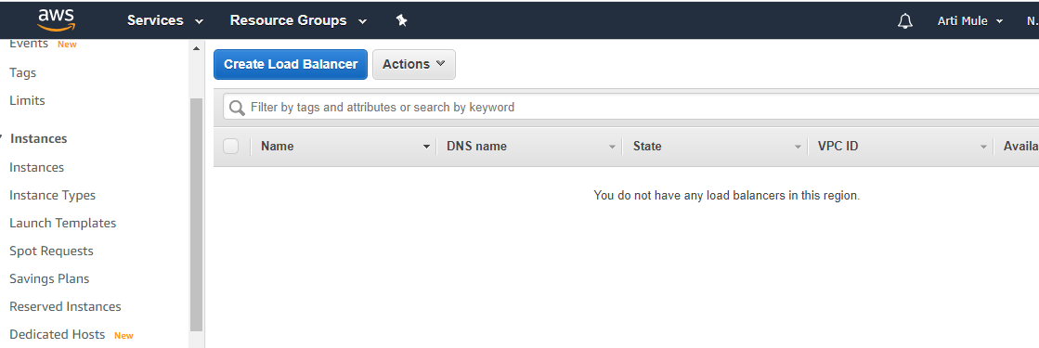

Select a load balancer type:

Elastic Load Balancing supports three types of load balancers: Application Load Balancers, Network Load Balancers, and Classic Load Balancers.For create create a Classic Load Balancer

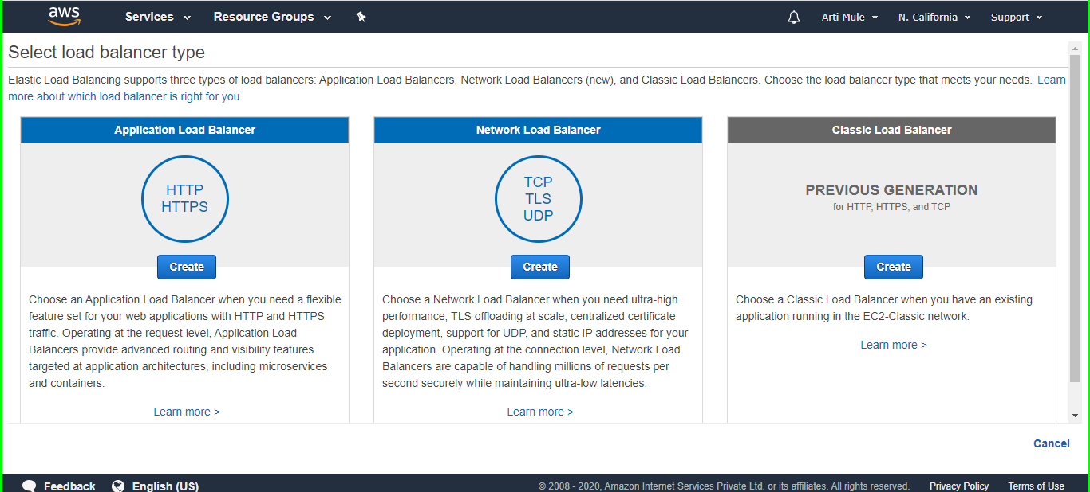

Then Continue Step by step create.

**Learning Outcome for Week 3:**

1. **Launching one windows instance in IIIS server**
2. **Ec2 - Classic load balancer**